Which pentagons tile the plan?

1. Introduction

The art of tilings originated very early in the history of civilization. As soon as man began to build he used stones to cover floors and the walls. The oldest tilings we find today originate from the Sumerians (4000 BC) and the most exquisite ones from Islamic culture especially from the Moors. However we should not forget that people create art based on the motives they are surrounded with. So like with most things tilings originate from the nature. By exploring structures of honeycomb and snowflakes in 1616 Johannes Kepler wrote the first mathematical paper about regular and semi-regular tilings. In a more recent history popularization of tilings was done by Dutch graphic artist M.C.Escher who tried to get a good mathematical background by studying Wallpaper groups. Regardlessly that tilings have a history of at least 6000 the science of tilings and patterns, by which we mean the study of their mathematical properties, is about one century old.

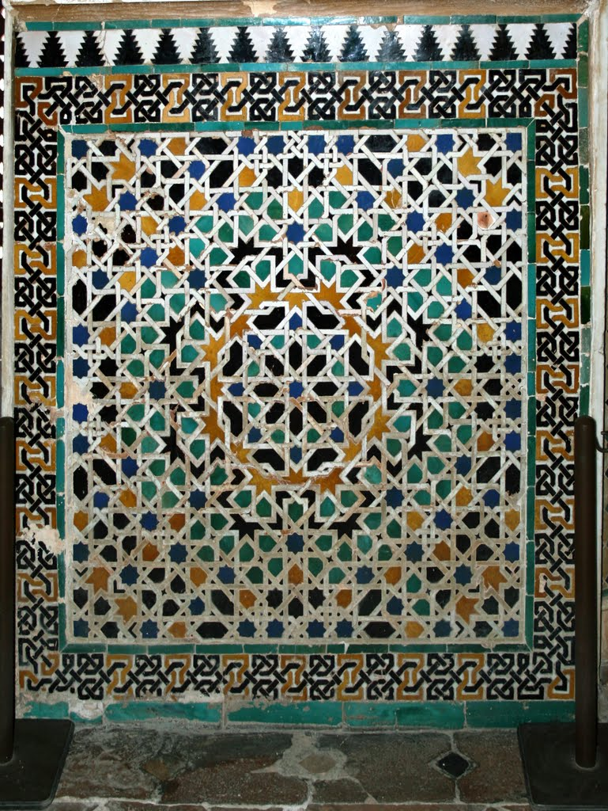

Alhambra, Granada, Spain Drawing by M.C. Escher

2. Basic notions

DEFINITION A plane tiling T is a countable family of closed topological disks T ={T₁, T₂, …} that cover the Euclidean plane without gaps and overlaps. More explicitly, union of T₁, T₂, … is to be whole plane, and the intersection of T_{i} are to be pairwise disjoint.

The T_{i} are called the tiles of T.

In the following example I would like to illustrate the notions of the edge and the vertex of the tiling as well as the side and the corner of the tile.

EXAMPLE

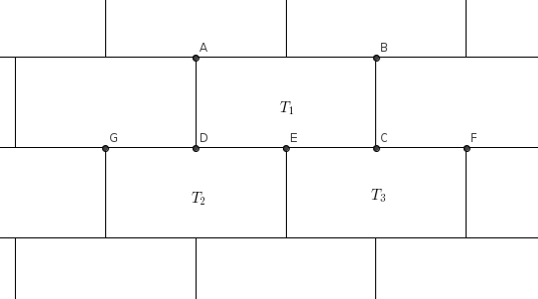

AB, BC, CD and AD are sides of a tile T₁ and A, B, C, D are the corners of the tile T₁. On the other hand DE and CE are edges of the tiling and D, E and C are vertices of the tiling as well as A, B, F and G. But one should notice that E is not corner of a tile T₁ nor DC is an edge of the tiling.

From now on I will concentrate on tilings where tiles are polygons called polygonal tilings.

DEFINITION If the corners and sides of a tile (polygon) coincide with the vertices and edges of the tiling we say tiling we say tiling by polygons is edge-to-edge.

DEFINITION Two tiles are called adjacent if they have an edge in common.

DEFINITION Two tiles are called neighbors if their intersection is non-empty.

DEFINITION Tiling T is called monohedral if every tile in the tiling T is congruent (directly or reflectively) to one fixed set T or, more simply, all the tiles are the same size and shape.

DEFINITION The set T is called prototile of T and we say that the prototile T admits the tiling T.

At first glance it may appear that monohedral tilings are very simple,perhaps even trivial, from mathematical point of view. At one time the great mathematician David Hilbert seems to have been of that opinion, since in his famous collection of unsolved problems he essentially ignored plane tilings and proposed questions concerning tilings in three or more dimensions. Now we know that this is not the case because not only that we lack the algorithm to determine whether a given set T is the prototile of a monohedral tiling, but there are good reasons to suppose that no such method (involving only a finite number of steps) can exist.

3. Symmetry

DEFINITION An isometry is any mapping of the Euclidean plane E² onto itself which preserves all the distances.

Thus if the mapping is denoted by σ: E²→E², and A, B are two points, then the distance between A and B is equal to the distance between their images σ(A) and σ(B).

It is not difficult to show (Cortex [1961, Chapter 3]) that every isometry is one of the 4 types:
1. Rotation about a point O through a given angle θ.
2. Translation in a given direction through a given distance.
3. Reflection in a given line L.
4. Glide reflection in which reflection in a line L is combined with a translation through a given distance d parallel to L.

For any isometry σ and any set S we write σS for the image of S under σ. By a symmetry of a set S we mean an isometry σ which maps S onto itself, that is σS = S. An isometry which maps every point onto itself is called identity isometry and is a symmetry of every set.

EXAMPLE Symmetries of the square
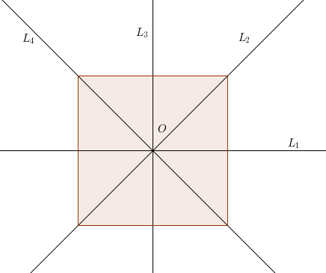
Reflection in four lines L₁, L₂, L₃ and L₄ are symmetries of the square. The other symmetries are the identity isometry, and the counterclockwise rotations through angles π/2, π and 3π/2 about the center O.
We do not distinguish between a counterclockwise rotation of θ and a clockwise rotation of 2π - θ, nor between a rotation of θ and a rotation of θ + 2πk, for any integer k. As symmetries, these are regarded as identical. We can conclude that the square has eight symmetries.

For any T we denote by S(T) the set of symmetries of T. The symmetries can be combined by applying them consecutively and the result is another symmetry. Because of this algebraic structure S(T) is known as a group, and the number of symmetries in S(T) is called the order of the group.

DEFINITION An isometry σ is a symmetry of tiling T if it maps every tile of T onto a tile of T.

For any tiling T we extend the notion from above and write S(T) for the group of symmetries of T.
If a tiling admits any other symmetry in addition to the identity symmetry then it will be called symmetric. If its symmetry group contains at least two translations in non-parallel directions then the tiling will be called periodic.
Let us note if T is any tile of T then every symmetry of T which maps T onto itself is clearly a symmetry of T. But the converse is not, in general, true. An example will illustrate why is that so.

EXAMPLE
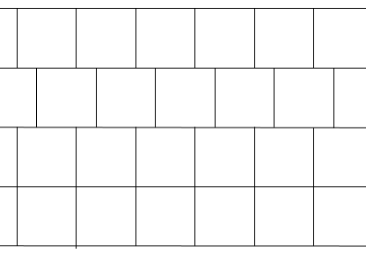

The only symmetry of T which maps a tile onto itself is the identity. On the other hand, the tile itself, being a square, has seven other symmetries.

DEFINITION Two tiles T₁, T₂ of a tiling T are said to be equivalent if the symmetry group S(T) contains a transformation that maps T₁ onto T₂; the collection of all tiles of T that are equivalent to T₁ is called the transitivity class of T₁.

DEFINITION If all tiles of T form one transitivity class we say that T is isohedral.

Note the distinction between isohedral tilings and monohedral tilings! In the example above we have a monohedral tiling that is not isohedral.

DEFINITION If T is a tiling with precisely k transitivity classes then T is called k-isohedral.

4. Convex pentagons that admit monohedral tilings

First thing we should note when we talk about the monohedral tilings by pentagons is that such a tiling is not possible with regular pentagons. It comes from a the simple fact that in every vertex of the tiling at least three tiles meet. Because the internal angle of regular pentagon is 108° it can not sum up to 360°. The same reasoning gives us that a monohedral tiling by regular n-gons is impossible for n≥7. The only possible monohedral tilings by regular polygons are tilings with triangles, squares and hexagons.
We will proceed by looking at types of convex pentagons that can admit monohedral tilings.
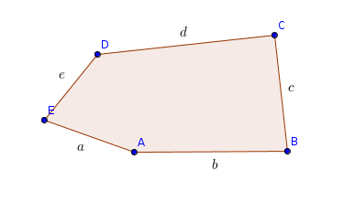
From now on we will use the following notation:

4.1. Types one, two, three, four and five

First five types that tile the plane monohedraly were discovered by the German mathematician Karl Reinhardt (1895 Frankfurt-1941 Berlin). He was a student of Ludwig Bieberbach that answered the first part of 18th Hilbert's problem and motivated Reinhardt to continue. In his thesis (“Über die Zerlegung der Ebene in Polygone” 1918) Reinhardt tried to give an answer to the question whether
there exists a polyhedron, which is not a fundamental region of any space group, that tiles 3-dimensional Euclidean space. In his thesis Reinhardt found five convex pentagons that tile the plane monohedraly.
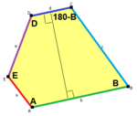
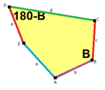
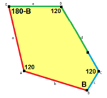

B +C = 180°, A + D + E = 360° c =e , B + D = 180° a = b, d =c + e, A = C = D = 120°

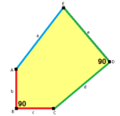
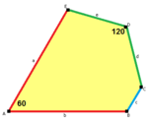

b = c, d = e, B = D = 90° a = b, d = e, A = 60°, D = 120°

It is very remarkable that all the five Reinhardt's types admit isohedral tilings. Moreover all the isohedral tilings with convex pentagons use only one of this five types.

THEOREM (Grünbaum, Shephard) There exist precisely 107 polygonal isohedral types of proper tilings by convex polygons; of these, 14 types have triangular tiles, 56 types have quadrangular tiles, 24 types have pentagonal tiles and 13 types have hexagonal tiles.

We could not cover in this paper all the terminology to understand this theorem but roughly speaking, two isohedral types differ if they have different symmetry groups or the relationship of tiles to their adjacent tiles differs.

4.2. Types six, seven and eight

Until 1935 it was thought that 2-dimensional anisohedral tilings do not exist. However, in that year, H. Heesch solved the 2-dimensional version of the Hilbert's 18th problem and demonstrated that the 2-dimensional isohedral tiles do in fact exist. Heesch's discovery opened the door to the possibility of additional types of convex pentagons being found. In 1968, half a century after Reinhardt published his result, Richard B. Kershner attempted to enumerate more convex pentagons that can tile the plane and found three more types. He claimed incorrectly that the list was complete. The examples that he found are 2-isohedral and edge-to-edge.
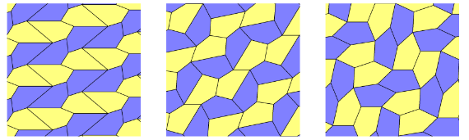
Type 6 Type 7 Type 8

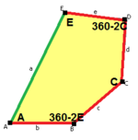
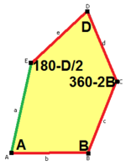
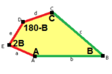

2B = E, B + D = 180°, B + 2E = 2C + D = 360° 2B + C = D + 2E = 360°
a = d = e, b = c b = c = d = e b = c = d = e

4.3. Type 10

In 1975 Martin Gardner wrote an article in Scientific America about which types of convex pentagons can tile the plane. In the same year, as a reaction to his article, a computer scientist from California Richard James III managed to enumerate the ninth type of convex pentagon that tiles the plane. We index it as Type 10. The tiling with this type is 3-isohedral and not edge-to edge.

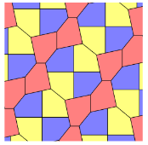
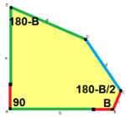

A = 90°, B + E = 180°, B + 2C = 360° Type 10
a = b = c + e

4.4. Types nine, eleven and twelve

Marjorie Rice, a Californian housewife, also had read Gardner's article and began her own attack on the problem. In 1976 and 1977 she discovered four new types. All four types admit 2-isohedral tilings. The tiling by Type 9 is edge-to-edge but the other three are not.
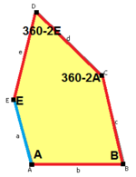
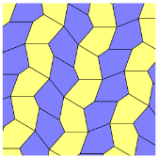

b = c = d = e
2A + C = D + 2 E = 360°

Type 9
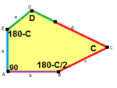
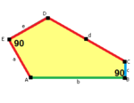
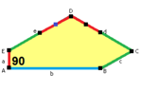

2a + c = d = e 2a = d = c + e d = 2a = 2e
A = 90°, 2B + C = 360° A = 90°, 2B + C = 360° B = E = 90°, 2A + D = 360°
C + E = 180° C + E = 180°

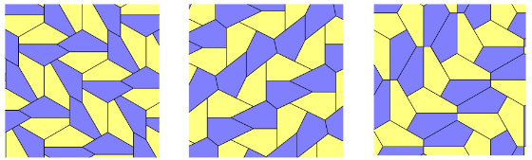
Type 11 Type 12 Type 13

4.5 Type 14

Rolf Stein, a graduate student from Germany, found the 14th type in 1985. For this type is interesting that is completely determined with no degree of freedom unlike the cases from above. The matching tiling is 3-isohedral and not edge-to-edge.
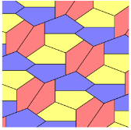

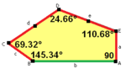

2a = 2c = d = e
A = 90°, B ≈ 145.34°,
C ≈ 69.32°, D ≈ 124.66°, Type 14
E ≈ 110.68°
4.5. Type 15

In October 2015 the mathematicians Casey Mann, Jennifer McLoud-Mann and David Von Derau from University of Washington discovered the 15th Type. Using a computer algorithm they completely determined the pentagon leaving no degrees of freedom. To narrow their search they used two important theorems. In 1985 Hirschhorn and Hunt proved that all equilateral convex pentagons which tile the plane are among first 14 types. In addition to this, in 2011 O. Bagina proved that all convex pentagons that admit edge-to-edge tilings of the plane are among the types 1-14. So the algorithm was searching for non-equilateral convex pentagons that tile the plane non-edge-to-edge. Using some theoretical results they proved that this limits the parameters of the search to a finite but large number of possibilities.
The algorithm can identify, for each number i, all possible convex pentagons that admit i-block transitive tilings.

DEFINITION An i-block transitive tiling T is a monohedral tiling by convex pentagons that contains a patch B consisting of i pentagons such that:
(1) T consists of congruent images of B
(2) this corresponding tiling by copies of B is an isohedral tiling
(3) i is the minimum number of pentagons for which such a patch B exists.
Such a patch B will be called an i-block and the corresponding isohedral tiling will be denoted by I.

EXAMPLE A pentagonal tiling T and a corresponding 2-block tiling I
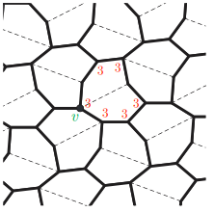
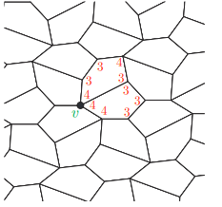

Tiling T by Type 7 pentagons Corresponding tiling I by 2-blocks

After few combinatorial results they came to the conclusion that for each positive integer i there is only a finite number of types of convex pentagons that admit i-block transitive tilings. In addition, note that any periodic tiling by convex pentagons is necessarily i-block transitive for some i. It would be reasonable to conjecture that any convex pentagon which admits a tiling of the plane admits at least one periodic tiling. If this conjecture is true, then all convex pentagons that admit tilings of the plane also admit at least one i-block transitive tiling. Thus, the pentagons found by this algorithm may well be all possible pentagons that admit tilings of the plane!
The algorithm is still running at the HYAK computing cluster at the UW. Until the 15th type was found classification of all pentagons admitting 1-, 2-, and 3-block transitive tilings was completed.
So there is a chance new, exciting examples will be discovered in soon future.

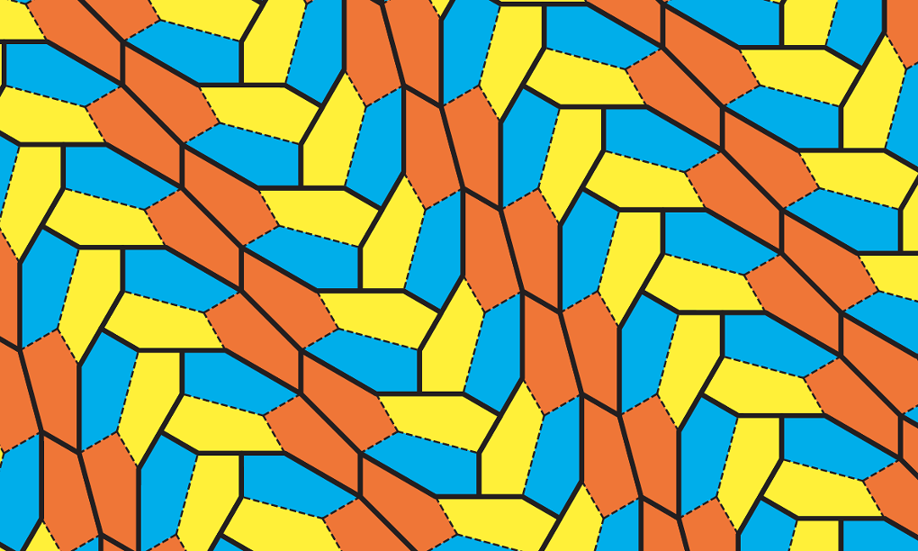
3-isohedral and non-edge-to-edge tiling by Type 15 pentagon

5. References

[1] Grünbaum, B. and Shephard, G. C. (1987). Tilings and patterns. W. H. Freeman and Company, New York.
[2] Mann, C. , McLoud-Mann, J. and Von Derau,D (2015). Convex pentagons that admit i-block transitive tilings. [Online] https://arxiv.org/pdf/1510.01186v1.pdf
[3] Scherphuis, J. Pentagon tilings. [Online] https://www.jaapsch.net/tilings/Tilings.pdf
[4] https://en.wikipedia.org/. Pentagonal tiling https://en.wikipedia.org/wiki/Pentagonal_tiling#Kershner_.281968.29_Types_6.2C_7.2C_8

Java applet that allows you to see lots of different tilings! https://www.jaapsch.net/tilings/
The images are taken from the above links or created by me in Geo Gebra.

Danijela, 15.2.2017.

